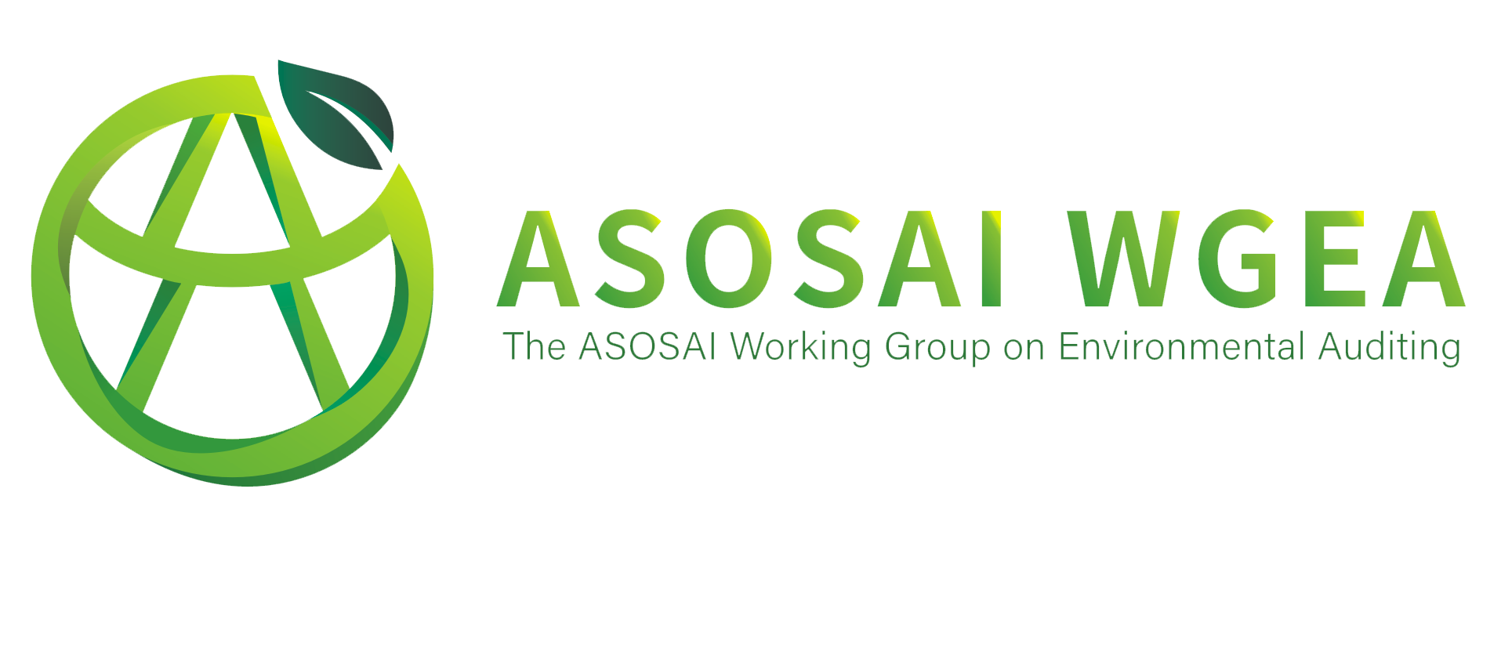

The 8th Seminar on Environmental Auditing and 8th Working Meeting of ASOSAI WGEA meeting minutes

Participant SAIs:
Bahrain, India, Maldives, Nepal, Kuwait, Mongolia, Malaysia, Thailand, Vietnam, Korea, Myanmar, Australia, Philippines, Pakistan, Bangladesh, Iran, Japan, Bhutan, Yemen, Oman, Mauritius, Indonesia, Iraq, China.

MEETING AGENDA:
25 October, 2021
The 8th Seminar on Environmental Auditing
14:00-14:30 (GMT+8) Opening of the meeting
- Opening speech
- All representatives take a group photo
- The Green Vision of Asia Award ceremony
- Unveils the new logo of the Working Group
Break
Topic: Promoting the Implementation of Government Environmental Responsibility through Auditing
14:40-15:10 (GMT+8) Keynote speech and Q&A session
15:10-17:00 (GMT+8) Introduction of relevant papers and Q&A session by Supreme Audit Institutions (SAIs)
Closing the day
26 October, 2021
Second day of the 8th Seminar on Environmental Auditing
Topic: Auditing of Response to Climate Change
14:00-14:30 (GMT+8) Keynote speech and Q&A session
14:30-15:20 (GMT+8) Introduction of relevant papers by SAIs
15:20-15:30 (GMT+8) Closing ceremony
Break

The 8th Working Meeting of ASOSAI WGEA
15:50-16:00 (GMT+8) Secretariat progress report
16:00-16:10 (GMT+8) Progress of the auditing cooperation project “Sustainable Transportation”
16:10-16:20 (GMT+8) Progress of the auditing cooperation project “Water Resources Management in Mekong River Basin”
16:20-16:30 (GMT+8) Progress of the scientific research cooperation
project “Themed on climate changes”
16:30-16:40 (GMT+8) Second online training project plan
16:40-16:50 (GMT+8) GreenShare Introduction
16:50-17:00 (GMT+8) The arrangements for the 9th Seminar on Environmental Auditing and Working Meeting of ASOSAI WGEA
17:00 (GMT+8) Conclusion

Monday 25 October

SEMINAR OPENING
HOU KAI (AUDITOR GENERAL OF CHINA),
QIN BOYONG (DEPUTY AUDITOR GENERAL OF CHINA)
Mr. Hou Kai, Auditor General of China and Chair of ASOSAI WGEA, attended the meeting and made an opening speech. He presented appreciation to all member SAIs for their support and cooperation, and reviewed the main works which WGEA had made since the 7th Working meeting of ASOSAI WGEA.

Mr. Hou Kai said that humans own one Earth and most of the participants lives in Asia. During the COVID-19 pandemic, all member SAIs shared a common destiny and helped each other. Protecting environment and keeping sustainable development became the same target of all countries, we were working hard to build an ecological civilization and a beautiful earth.

12 December, COP15 was held in Kunming,China. To respond to the climate change, the world was facing the common tasks of green and low carbon economic. Chinese government has been applying more strict policies and measures to accelerate green development. China will strive to peak carbon dioxide emissions before 2030 and achieve carbon neutrality before 2060. SAI China would actively conduct relevant environmental auditing and provide governance on carbon reduction.
In the next session, Ms. Qin Boyong, Deputy Auditor General of China, introduced the relevant information of Green Vision Award. 7 members of ASOSAI WGEA submitted their application and their application works were reviewed by the judge panelist consisting of supreme audit institutions. The final winner was State Audit Office of the Kingdom of Thailand.. Mr. Hou Kai presented the trophy to winner SAI. Secretariat played the video on the details of environmental auditing conducted by the State Audit Office of the Kingdom of Thailand in recent years. Mr. Prajuck Boonyoung, Auditor General of State Audit Office of the Kingdom of Thailand, delivered the acceptance speech.

For a better public image of ASOSAI WGEA, the Secretariat started an activity to design an official logo for the WGEA in 2021, and solicited the draft design among young students. Mr. Hou Kai unveiled the new official logo, and Yuan Meng, the designer of new logo, introduced the design concept and meaning of this logo. She explained the details symbolic meaning of overall design, shape and color selection.

SEMINAR SESSION (Audit Promoting Government Accountability for Environment)

Presentation
Li Haisheng (President of the Chinese Research Academy of Environmental Sciences)
Mr. Li introduced the progress of ecological and environmental protection in China recent years from three aspects, and the role played by environmental science and technology and environmental auditing. He expressed that China had made remarkable progress in ecological and environmental protection during the 13th Five-Year Plan period, including launching the battle against pollution, and the ecological and environmental quality has significantly improved across the country. The legal construction of ecological and environmental protection had seen remarkable progress, 25 laws and administrative regulations have been formulated and revised. He also mentioned that environmental science and the technology have played an important role in supporting the battle against pollution, and listed 7 typical campaigns for science and technology supporting environmental protection. The innovative 1+X mode for science and technology was appointed. Under the research-production-application-feedback-improvement working mode, governments overcame the challenge of having ideas but lacking methods.

Also, Mr. Li illustrated how environmental auditing effectively urged governments to fulfill the environmental protection responsibility. Conducting tenure-based natural resources accountability audit of leading officials is an innovation in China’s progress of ecological civilization. Firstly, auditing reviewed environmental accountability of leading officials and addressing the lack of foresight, such as emphasis on development over protection and emphasis on short-term interests over long-term development. By strengthening cooperation with departments in charge of natural resources and ecology and environment, audit institutions can better utilize results of the audit, enhance joint supervision. Secondly, CNAO carried out special-purpose audits and real-time audits on policy implementation to help rectify problems and improve systems and mechanisms. The audits improved the efficiency of environmental protection funds, regulated resource exploitation and environmental protection, and improved the pollution control capability.

At the end, Mr. Li put forward five suggestions that promoting sychronized and coordinated efforts to reduce pollution and carbon emissions, formulating and releasing resource-environment audit guidelines and manuals, strengthening the application of science and technology, strengthening the connection between audit and other systems, and enhancing the international cooperation and communication.

Country Paper: SAI Australia
SAI Australia described the shared environmental responsibility of each level of government. The agriculture, water and the environment portfolio is responsible for advising the Australian Government and implementing programs on the environment, water resources, and Australia’s agricultural, fisheries and forestry industries. From 2019-20 to 2020-21, the ANAO tabled 84 performance audits, with nine audits relating to the environment and agriculture. The Auditor-General published the annual audit work program in July each year, and the purpose of the annual audit work program was to inform the Parliament, government sector entities and the public of the audits the ANAO proposed to deliver throughout the financial year. SAI Australia also expressed the risk in environment and the themes from recent audits, and showed the weaknesses in management of probity and conflicts of interest. Furthermore, SAI Australia introduced the key messages for the public sector and two levels audit impacts. The audit experience which use of data analytics and systems assurance specialist, data and record-keeping and sample testing were shared at the end.

Country Paper: SAI Bahrain
SAI Bahrain introduced that the National Audit Office of the Kingdom of Bahrain (NAO) had established a strong interest in environmental issues and took several steps for promoting government accountability for environment by conducting audit assignments and issuing recommendations in audit reports. The main steps included environmental audit in the NAO’s strategic and annual plans, environmentally related audit assignments, capacity building in relation to environmental audits, and utilization of IT and virtual technologies during COVID-19 Pandemic. SAI Bahrain emphatically expressed an example of environmental audit assignments and shared the audit methodology.

Country Paper: China
SAI China reviewed how audit promoted the realization of the SDGs by environmental auditing across the world. China is committed to combating pollution. Audit institutions have accumulated some successful experience by promoting full coverage of supervision through auditing and actively serving sustainable development. SAI China shared how audit promoted the government’s fulfillment of environmental governance responsibility. It contained the role of government, responsibility of central and local governments, the government’s problems in environmental governance, and the mode of audit intervention. Especially, SAI China illustrated the audited entities and major considerations, the overall audit principles, and the main audit content of tenure-based natural resources accountability audit on leading officials. Also, SAI China shared the opportunities and challenges faced by audit urging the government to better fulfill environmental governance responsibilities.

Country Paper: SAI Indonesia
SAI Indonesia illustrated an on-going performance audit on community-based clean water and sanitation infrastructure provision in support of the healthy lifestyle movement. Clean water and sanitation provision were the major projects of the national agenda. The programs on clean water and sanitation provision would bring a better condition for the environment. SAI Indonesia introduced the relationship between SDGs and National Targets on clean water and sanitation infrastructure. SAI Indonesia held the preliminary performance audit for 30 days and found 7 problems on drinking water and sanitation. Also, SAI Indonesia listed 4 questions on audit procedures and shared 9 tentative audit findings.

Country Paper: SAI Malaysia
SAI Malaysia illustrated the management of highland, hill, and slope development activities to explain how audit promoted government accountability for environment. SAI Malaysia explained the importance of this topic that audit was carried out to improve the implementation management and monitoring of the management of development activities for highland, hill and slope areas and impact on the environment. The objectives and methodology of this audit also was mentioned . For the audit findings, SAI Malaysia introduced one output achievement and one outcome achievement, and showed 6 types of development activity management. SAI Malaysia also shared their recommendation on this audit at the end.

Country Paper: SAI Philippines
SAI Philippines introduced The Commission of Audit (COA) which the country’s Supreme Audit Institution, and explained the role of COA in the Public Sector Governance. SAI Philippines showed the areas of environmental audits scheduled for CYs 2021-2023 along with key audit points including forest resources, mineral resources, protected areas and natural parks and species diversity/endangered species, solid waste management program, and national climate change action plan. SAI Philippines also mentioned how environmental audits performed, and 7 challenges and action taken in the conducting of environmental audits. The lessons learned and insights were shared at the end.

Country Paper: SAI Vietnam
SAI Vietnam introduced the auditing on the water management in Mekong River Basin toward sustainable development. This topic was also the cooperative audit project of ASOSAI WGEA. The State Audit Office of Vietnam (SAV), with its role as an independent constitutional agency and its functions for auditing the management, use of public finance and/or public property. The audit had the participation of 3/6 SAIs of the MRB’s countries including the SAV, the Office of Auditor General of Thailand and the Office of Auditor General of Myanmar. SAI Vietnam illustrated the achievements, shortcomings, and limitations of the audited entities. Based on the audit findings, SAI Vietnam listed a few recommendations to the government, ministries, and local authorities in strengthening effective management and monitoring of water resources. They thought the cooperative audit had been conducted successfully, and brought many added values in water resources management for countries in the Mekong river basin.

(END OF FIRST DAY SEMINAR MEETING)

Monday 26 October

Seminar session (Audit on Climate Change )

PRESENTATION
Jian Liu (Director of the Science Division, UNEP),
Dr. Liu Jian is currently the Director of the Science Division, the UN Environment Programme (UNEP). From March 2017 to February 2021, he also served as UNEP Chief Scientist as an adjunct to his function as Director of Science Division. Dr. LIU Jian has over 30 years of professional experience in science and policy, in the specific domains of ecosystems management, agriculture, environment and climate change at national, regional and global levels, in particular in developing countries.

Dr. Liu Jian expressed that humans now had a major impact on the earth, of the combined biomass of mammals on earth, human population now constituted about a third and livestock nearly two thirds, while wild mammals now amounted to less than 5 percent. Human development was largely fueled by a tripling in the extraction of natural resources and energy over the past 50 years. While the economy thrived,due to increased efficiency, we are still far from a decoupling of the economy from environmental degradation.
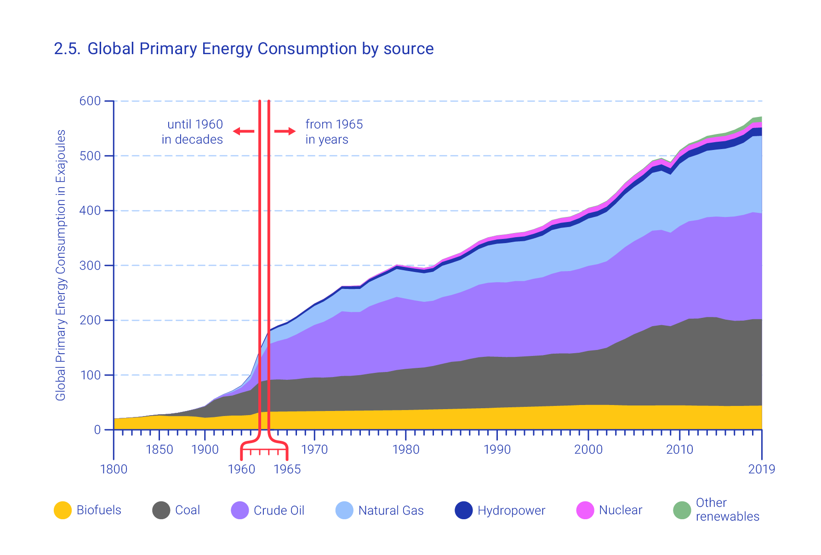
Dr. Liu Jian also illustrated the above figure to show that growth in global primary energy consumption has been largely attributed to the growth in fossil fuels. About two thirds of the warming caused by greenhouse gases is due to carbon dioxide, mostly originating from the use of fossil fuels.
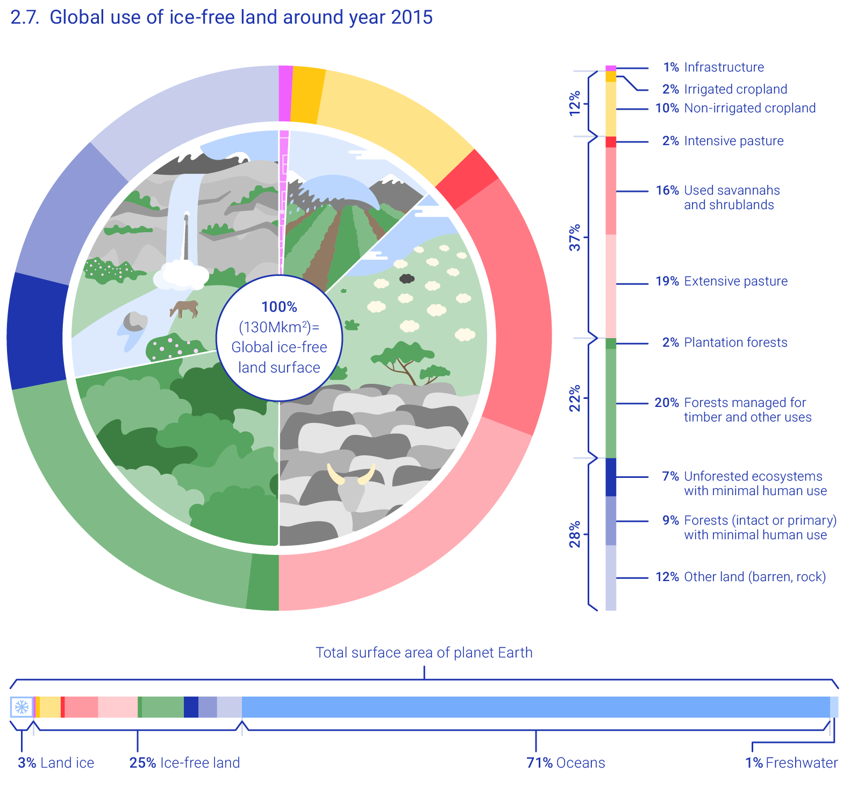
Dr. Liu Jian used another figure to show that three quarters of the land and two thirds of the oceans are now impacted by humans. 1/4 of global warming results from activities related to land-use, 1/4 land has been radically transformed, and remaining near-natural land is projected to be only 10 percent by 2050. Then he used three figures to explain some definations of the production and release of chemicals increasing rate, human emissions of greenhouse gases increasing rate, and biodiversity decreasing accelerating rate.

Dr. Liu Jian reviewed the risk associated with climate change and environmental degradation that threatens the achievement of the SDGs. He thought human knowledge, ingenuity, technology and cooperation can transform societies and economies and secure a sustainable future. Also, closing the Greenhouse Gas Emission gap and aligned actions for protecting and restoring life on earth were mentioned.

Country Paper: SAI India
SAI India illustrated some global concerns on climate change, like pollution, industrialization, livestock and etc. They introduced the climate change institutional framework of India and listed a sort of national action plan on climate change. SAI India concentrated on the sources of GHG emissions, mitigation measures, adaptation measures, and regulation, monitoring and supervision to conduct audit projects on climate change. They illustrated 4 audit cases which vehicle emission, renewable energy sector, Rejuvenation of River Ganga (Namami Gange), and environmental clearance and post clearance monitoring, and introduced the audit objectives, methodology, and findings of each audit case.

Country Paper: SAI Mauritius
Mauritius is located approximately 2000 kilometers to the south eastern coast of Africa and lies east of Madagascar. SAI Mauritius introduced the basic country information and the main environmental threats. It included the climate change, loss of biodiversity, soil degradation and others. SAI Mauritius expressed some effects of climate change and concluded the greatest risks Mauritius would be facing in the future. Facing to the climate change, Mauritius government set up a National Disaster Risk Reduction & Management Council and emphasized on building a climate-change resilient nation to meet adaptation and mitigation objectives. At same time, SAI Mauritius undertook three types of audit including financial audit, compliance audit, and performance audit. Some audit cases were illustrated and the key findings of each case were reviewed. The challenges on auditing were mentioned by SAI Mauritius.

Country Paper: SAI Indonesia
SAI Indonesia took an example auditing case to demostrate its active role in alleviating climate change and promoting low-carbon development. They reviewed the principle of Greenhouse effect and the international responses. SAI Indonesia introduced the programs of the government of Indonesia to tackle climate change. They developed a series of low-carbon development policies, and improved resilience of coastal and marine sector, water security, agriculture sector, and public and environmental health. For climate change audit, SAI Indonesia focused on renewable energy development, bio-diesel provision, city gas network development, social forestry management, seawall construction, Citarum watershed pollution control and management, and swamp land optimization. The improvement and recommendations for each audit case were listed.

Seminar Closing
QIN BOYONG (DEPUTY AUDITOR GENERAL OF CHINA)
Ms. Qin Boyong gave a speech for 8th Seminar on Environmental Auditing closing session. She reviewed all activities included Green Vision Award ceremony, the new official logo inauguration ceremony, two auditing theme speeches, and country paper sharing.

Ms. Qin Boyong expressed that environmental issues had attracted most attention across the globe and in Asia. In this context, the ever-increasing importance of environmental auditing called for all Asian environmental auditors to enhance our capacity and performed our tasks well. She encouraged all member SAIs to continue working together, for the sustainable development of environment in our region, and for the continued protection of a Beautiful Asia.

(END OF SEMINAR MEETING)

WORKING MEETING

WORK PROGRESS REPORT
(SECRETARIAT OF ASOSAI WGEA)
The Secretariat of ASOSAI WGEA reported the work progress and recent achievement since the 7th Seminar on Environmental Auditing and 7th Working Meeting of ASOSAI WGEA, and expressed the follow-up work plan.

For now, ASOSAI WGEA had 33 members and 1 observer. The Secretariat hoped more country SAIs could join in the WGEA, and shared their successful experience on environmental auditing in future.

Secretariat reported the progress of 2nd cooperative audits and research project. Between the end of 2020 and the beginning of 2021, ASOSAI WGEA held the online meetings to kick off two cooperative audit projects on Water Resource Management in the Mekong River Basin and Sustainable Transport. The project of Water Resource Management in the Mekong River Basin had conducted the scheduled training while auditors from Vietnam and Thailand have completed their parts on field audit. All parties of Sustainable Transport project were working on the agenda by preparing audit plans.

The selection process of 2020 Green Vision Award was officially started early this year, and the Secretariat also started an activity to design an official logo for WGEA in 2021.

Secretariat introduced the situation of 1st online training which was held in last year. The training was focusing on the topic of solid waste. The experts from China and Malaysia gave two lectures on solid waster pollution and environmental management and how to conduct the solid water management audit. More than 160 auditors from 16 SAIs participated in this training.

For future priorities, ASOSAI WGEA, supported by various online techniques, will continue to fulfill its obligations. Firstly, Secretariat would promote the cooperative audit and research projects among the 2020-2022 Work Plan. Secondly, the 2022 Green Vision Award preparation works would be initiated and the new round of Judge Panelist would be organized. Thirdly, Secretariat would promote the communication with each group member SAIs and make full use of the GreenShare platform.

PROJECT ON SUSTAINABLE TRANSPORT
(SAI CHINA)
SAI China, as the co-leader of project on Sustainable Transport, reported the progress of this project. The definition and principle of sustainable transport was reviewed at the beginning. The process of cooperative audit project included the preparatory work, project launch, project implementation and project summary. SAI China also illustrated a few cases and typical experiences from Malaysia, Thailand, and China, such as the audit of sustainability of urban land public transportation in Malaysia, sustainable transport audit in Thailand, and the sustainable transport audit in Changsha-Zhuzhou-Xiangtan region in Hunan province of China. Next stage, the project lead would organize a meeting of Supreme Audit Institutions of the 7 countries to exchange opinions, and formulate the summary report based on the audit reports delivered by each participated country.

COOPERATIVE AUDIT ON WATER RESOURCES MANAGEMENT IN THE MEKONG RIVER BASIN
(SAI VIETMAN)
SAI Vietnam had introduced the lasted progress of the cooperative audit in the first session.

RESEARCH PROJECT ON CLIMATE FINANCE
(SAI THAILAND)
SAI Thailand started the introduction by reviewing the key question: How SAI can promote the transparency and accountability in the climate finance. Two research objectives which to study the role of SAIs on auditing climate finance and to develop the conceptual framework for auditing climate finance were mentioned. Also, the utilization of research literature review and research methodologies were concluded. SAI Thailand planned to finish the second progress report in the end of 2021 and start the draft circulation on January 2022.

SECOND ONLINE TRAINING WORK PLAN
(SECRETARIAT OF ASOSAI WGEA)
The Secretariat reviewed the purpose of conducting the online training: provide knowledge sharing opportunities to build up member SAIs’ environmental auditing capacity. Based on the global common concerns and the discussion of 18th SC meeting, the Secretariat listed three most frequent topics. The first topic was carbon neutrality, the second topic was land use and protection, and the third topic was biological diversity. Secretariat generally introduced the basic information of each topic. The second online training theme would be ensured by the mini-survey by all member SAIs after the working meeting. The Secretariat welcomed the member SAIs who were interested in this pilot training, and the colleagues who are willing to be experts, to work with together closely to make this task possible.

INTRODUCTION OF GREENSHARE
(SECRETARIAT OF ASOSAI WGEA)
In order to bring more activities to the ASOSAI WGEA website and enhance the exchange of environmental audit information among member SAIs, the Secretariat proposed to add a new column to the website, which will enable members to share published policies or laws on resources and environment management of their respective countries, and environmental audit cases, methodologies, working progress and results. The column was named GreenShare and the Secretariat introduced the overview of this column. Secretariat encouraged all members to kindly provide relevant information on a monthly basis.

THE NINTH SEMINAR ON ENVIRONMENTAL AUDITING WORK PLAN
(SECRETARIAT OF ASOSAI WGEA)
The 9th Seminar on Environmental Auditing is planned to be held in 2022. The Secretariat would keep communication with all member SAIs to discuss the date, venue and theme of the 9th Seminar. ASOSAI WGEA would go hand in hand with its member SAIs and relevant stakeholders, and worked with even greater initiative and enthusiasm on Asia’s environmental auditing work.

(End of Working Meeting)

