Country Paper:

IT Application in Environmental Audit

SAI India
Introduction:
We live in an age marked by ever widening horizon of scientific inventions and frontiers of modern technology. Today technology is omnipresent and plays a pivotal role. Governments rely increasingly on technology for a variety of tasks including delivery of public goods and services. IT applications provide medium for interaction between all the stakeholders of schemes, programmes and projects. IT systems also provide medium for application of other modern technology like Remote Sensing, Geospatial Information System (GIS) and Global Positioning System (GPS) used by the Governments around the world for a variety of purposes.
In order to keep pace with enormous developments in the realm of technology and embrace the evolving opportunities, SAI India formulated Big Data Management Policy, 2015 and created a dedicated Centre for Data Management and Analytics (CDMA). It is a major initiative for institutionalizing the practice and use of data analytics by SAI India. These Guidelines draw on the existing guidelines on Performance Auditing, Compliance Auditing, Financial Auditing, Auditing Standards and other relevant instructions and manuals in SAI India. It also provides for engagement of external experts in such areas as data handling, applying advanced data analytic techniques or management of data repository. There is a dedicated wing for Environment Audit covering the Union Ministry of Environment Forest and Climate Change, Ministry of New and Renewable Energy and Ministry of Water Resources, River Development and Ganga Rejuvenation.
SAI India emphasizes use of data analytic results at various stages of audit (planning, execution or reporting) to derive insights or evidence during the audit process. At the audit planning stage, identification of issues, unit planning and sample design can draw from the data analytic results. At the audit reporting stage, data analytic results drawn at the execution stage are presented for better appreciation of audit findings.
Use of IT in Environment Audit:
Audit domain of the Environment Audit wing comprises of three main Ministry’s viz, Ministry of Environment Forests and Climate Change, Ministry of New and Renewable Energy and Ministry of Water Resources, River Development and Ganga Rejuvenation, which does not usually maintain elaborate database. Therefore, use of big data and data analytics is relatively limited and mainly utilized in the reporting of audit findings. Therefore, data software like excel serves the purpose for collection, analysis and reporting. Moreover, we use Tableau for data visualization and infographics in audit reports. Furthermore, remote sensing is emerging as an important area for audit for ‘change detection’ and ‘area estimation’, very useful in audit of sectors such as infrastructure projects. Geo-tagging and crowd sourcing applications have scope for application in pollution abatement and river cleaning programmes etc. for tracking discharge in to the rivers and monitoring the progress of asset creation, their maintenance and delivery of quality of service.
Usage of Excel:
We have been using simple IT tools like excel for primary data collection, data organization, analysis and presentation through charts and graphs. A sample of simple data representation using excel is indicated below (Audit report on CAMPA), wherein we have indicated trend of growth of funds over a period of time, using excel.
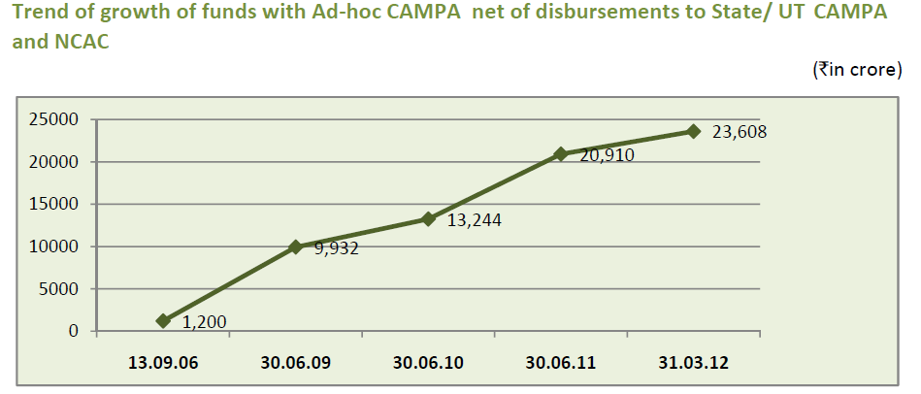
Another use of excel for data representation shown below, which is an extract from audit report on CAMPA. We have used excel to represent position and distribution of funds available with the Authority.
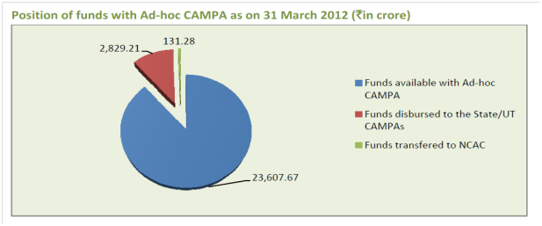
Similarly, we have used excel for studying the water quality data in terms of benchmark parameters (Dissolved Oxygen, Biological Oxygen on Demand and Total Coliform levels) in 10 selected towns of four States, during 2012-13 and 2016-17. Primary data against the benchmarks were collected in excel and analysed for deviations. From the data we inferred that the quality of water was fit for outdoor bathing as DO, BOD and TC level were within the prescribed water quality criteria during 2012-13 and 2016-17 between only two towns. In six towns of three States, DO declined from 2012-13 levels. BOD was higher than the prescribed limit in the three towns of one State. During 2016-17, TC levels in all the cities of three States was very high ranging between six to 334 times higher than the prescribed levels. Thus, water quality in eight out of 10 towns did not meet the prescribed standards on all the parameters.
Usage of Tableau:
We have been using Tableau for better representation and visualization of data in our audit reports. We use Tableau in such cases where data is complex. Tableau with its inherent capability to handle complex data, inbuilt visualization formats as well scope for custom visualizations enables data visualizations in an effective manner. A sample of data representation using Tableau (extracted from audit report on Environmental Clearance and Post Clearance Monitoring), depicting instances of non-compliances to different stipulations, is shown below. As the data available was complex and not just two dimensional, usage of Tableau lent it an effective rendering of complete picture. 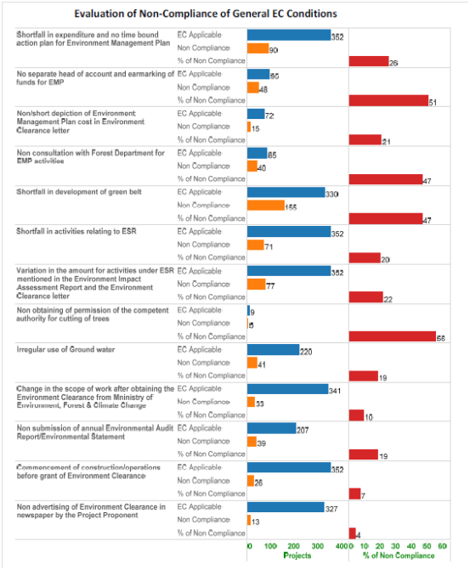
Experience and Challenges:
Usage of uniform data input and data visualisation software like Tableau aids in use of graphics and visualizations involving complex data and thereby enhancing the quality of audit reports. However, agencies in our audit domain usually do not maintain large data. As a result, the tools have been largely used in drafting of reports vis a vis other audit procedures. Though, the potential for usage of remote sensing and satellite imagery is emerging as an audit tool, it is limited due to availability of current data in the public domain, low resolution imageries and capacity constraint. More proactive engagements are likely to come in further audit assignments involving the use of remote sensing and other emerging technologies as it saves considerable resources, gives fair indication of risk areas, aids in estimation of changes over time and assessing the overall progress of any work.

Compensatory Afforestation Management Funds Management and Planning Authority

