Implementation of Mobile Geospatial Technology - ArcGIS Survey123 on Health Facilities Performance Audit at Coastal Village
The Government of Indonesia has demonstrated a strong commitment to implement the SDG agenda by synchronizing its strategic development plan and Programs of National Medium-Term Development Plan (RPJMN) 2015-2019 with SDG. This commitment has been carried out through the enactment of Presidential Decree Number 59 of 2017 on the Implementation of the Achievement of Sustainable Development Objectives. The Presidential Decree aims to maintain the sustainability of community social life, environmental quality, inclusive development, and growth.
To review and follow up the implementation of the SDG agendas implementation, the United Nation established a platform for SDG stakeholders called the High-Level Political Forum (HLPF). The HLPF sets an annual theme that becomes the priority reference for the implementation of the SDG goals. In 2017, the theme of HLPF is Eradicating Poverty and Promoting Prosperity In A Changing World. These themes cover seven goals of SDGs:
- Goal 1. End poverty in all its forms everywhere
- Goal 2. End hunger, achieve food security and improved nutrition and promote sustainable agriculture
- Goal 3. Ensure healthy lives and promote well-being for all of all ages
- Goal 5. Achieve gender equality and empower all women and girls
- Goal 9. Build resilient infrastructure, promote inclusive and sustainable industrialization and foster innovation
- Goal 14. Conserve and sustainably use the oceans, seas and marine resources for sustainable development
- Goal 17. Strengthen the means of implementation and revitalize the Global Partnership for Sustainable Development
Eradicating poverty is a priority of the Indonesian government. The RPJMN 2015-2019 has set poverty reduction target of 7-8% 2019. According to Statistical Bureau of Indonesia, the number of poor people in Indonesia reached 27.77 million people (10.64 percent) in March 2017. To achieve the RPJMN target, an aggressive approach to poverty reduction effort through empowerment of poor people is needed to help them to transform their own lives.
Indonesia is the largest maritime country in the world, making Indonesia become one of the world's largest suppliers of fishery products. According to FAO, in 2014, Indonesia is the second largest country for the production of capture fisheries with the production of about 6 million tons per year. Therefore, coastal areas play an important role that contributes to Indonesia economic growth. However, this condition is not aligned with the welfare of coastal communities. Based on BPS data in 2014, the number of the coastal villages were 12,827, and 23.79% of them (3,051 villages) were categorized as poor villages. These conditions indicate the crucial need for comprehensive policies that can optimize the utilization of potential fisheries production that encourages eradicating poverty.
In the RPJMN 2015-2019, GOI set a national target that put forward the role of marine economy and synergy of national marine development. Taking into account these national goals and the HLPF 2017 theme, SFM is the right approach to optimize the potential utilization of fisheries in Indonesia.
Sustainable fisheries management (SFM) is an integrated process to ensure the balancing of environmental, economic and social aspects to accomplish continued productivity of fishery resources (FAO, 2003). SFM aims to achieve the optimal and sustainable utilization of the fishery resources for the benefit of humankind and the ecosystem. The implementation of SFM will be able to contribute to the achievement of four of the seven SDG goals in HLPF 2017, i.e., end-poverty, end hunger, healthy living and promoting well-being for communities and conservation and sustainably use the oceans.

There are three aspects that can be identified as the key factors for effective SFM which are:
- Environmental aspect
In term of environment aspect, the Government of Indonesia has endeavored to protect the ocean by establishing marine protected areas (MPAs). MPAs are considered as an effective instrument to preserve the productivity of marine ecosystem regarding fish stock. According to Government Regulation No. 60 of 2007 on Fishery Resources Conservation, the definition of MPA is a marine area which has been protected and managed through zoning system, to achieve sustainable fishery management. The GOI has established marine conservation areas since 2009 covering 16.1 million hectares and based on the national target stated on Presidential Regulation 59 of 2017; the area will be increased to 20 million hectares. Marine conservation area of 16.1 million hectares can be seen in the picture below (figure 1)
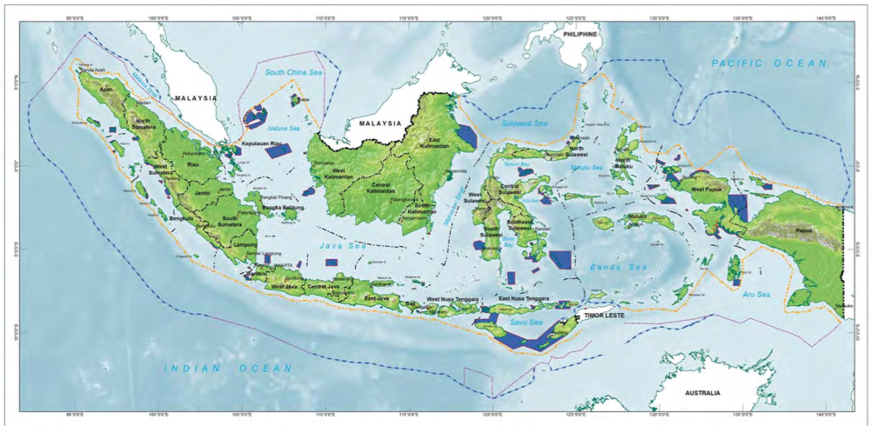

Figure 1. Marine Protected Area Distribution
To manage MPAs effectively, ensuring availability of regulations and law enforcement are crucial. The laws and regulations for sustainable use of marine resources and environmental protection are addressed below.
- Regulation of the Minister of Marine Affairs and Fisheries No. 56 of 2014 on Termination of Temporary (Moratorium) Licensing Business fisheries in Regional Fisheries Management. This regulation is also concerning on temporary suspension on the foreign vessel to operate in Indonesia ocean.
- Regulation of the Minister of Marine and Fisheries No02 Year 2015 on the Prohibition of the Use of Fishing trawler Hela (trawls) and trawl Pull (Seine Nets) in Regional Fisheries Management of Republic of Indonesia;
The primary objective of those regulations issuance is to reduce excessive exploitation of marine resources that could ultimately damage the marine ecosystem. The implementation of regulations will significantly affect the sustainability of marine ecosystems, as small fish and corals are protected from excessive damage and exploitation.
- Economic aspects
From the economic point of views, the Government of Indonesia has implemented several programs to improve fishermen's income with the ultimate goal of reducing the poverty level of fishers. The programs that have been implemented by the government are:

- Indonesia Fisheries aid program
The GOI has budgeted Rp79 billion in 2017 for the fishing aid program. This program is a grant awarded by the Government to compensate for the ban on the use of trawlers, which is considered an unsustainable fishing method. The government has distributed new fishing equipment that has been designed to be environmentally friendly. This fishing tools will prevent fishers from unintentionally catching young fish and damaging corals. Moreover, the government also provides fishing vessels assistance program with the budget of Rp467 billion to increase fish production.
- Distribution of fishery product program
The Government of Indonesia has established a program to improve the effectiveness of fishery product distribution. The President has issued Presidential Instruction No. 7 of 2016 that contains instruction for ministers, the National Armed Forces, the National Police, government agencies and governors to take action on the acceleration of National Fisheries Industry Development. It is expected that the instruction will help fishers to market their products and will improve their income.
- Social aspects
From a social perspective, toward the implementation of SFM, the government has been focusing on the improvement on the health of fishers. Fishers are one of the most dangerous occupations since they work in an extreme condition. Health risk factors among fishers need to be highlighted. Based on the National Social and Economic Survey of 2013, about 25 percent of fishers have health problems in the past month when surveyed. Some of them claimed that the health disorders interfered their activities and impacted their household economy. In the bigger scale, this condition will result in degradation of fishery production.
As healthy and resilient fishers will affect the sustainable fishery management, the government need to emphasize its effort on providing healthcare facilities for fishers. However, government-owned healthcare facilities in coastal areas are still inadequate. Based on BPS data of 2014, from 3,051 poor villages in the coastal area, only 14,14% have been served by Health Community Center (Puskesmas). Puskesmas provides basic healthcare service for fishers. If the fishermen's health level drops, their productivity will decrease. GOI has considered the fishermen’s health issue as an important factor of SFM. Therefore the government issued Presidential Decree No. 10of 2011 on improving the welfare of fishers that focus on health services through the improvement of puskesmas services.
Currently, BPK is conducting a performance audit on the improvement of puskesmas services. Most of the areas that were chosen as audit sample in Eastern Indonesia, where on the coast and the patients are fishermen. In this audit, BPK utilised GIS software as audit tools to collect audit evidence, to formulate audit conclusion and to improve the quality of audit report. The GIS software that has been used for this performance audit is ArcGIS Survey123. This software is a data collection GIS application using survey form. Once the user inputs the data, the software will immediately analyze and visualize the data. The questionnaire on ArcGIS Survey123 can be tailored to the purpose of the audit.

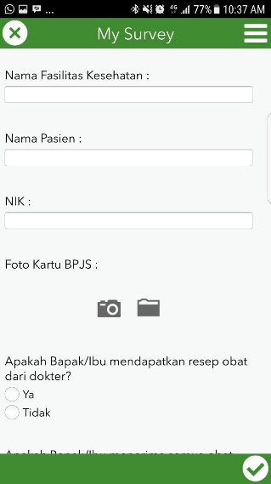
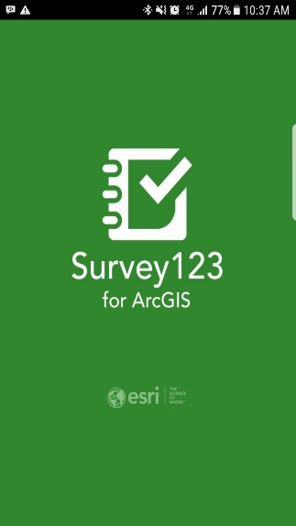
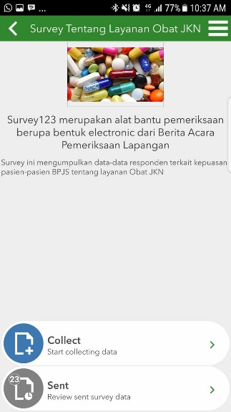
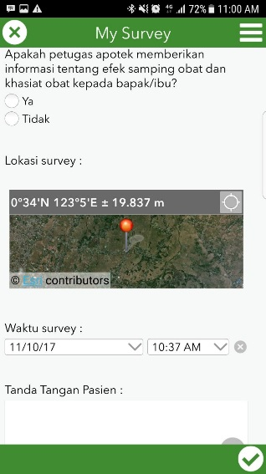

Figure 2. Survey123 application view

By utilizing this software, BPK can create a map that shows the performance of puskesmas based on the questionnaires that were submitted by the respondents (fishers). The questionnaire results in patient satisfaction with healthcare are then mapped and analyzed using ArcGIS Operation Dashboard software so that the map can be generated as follows:

Graphic of Satisfactory Level
Average of Health Care Cost
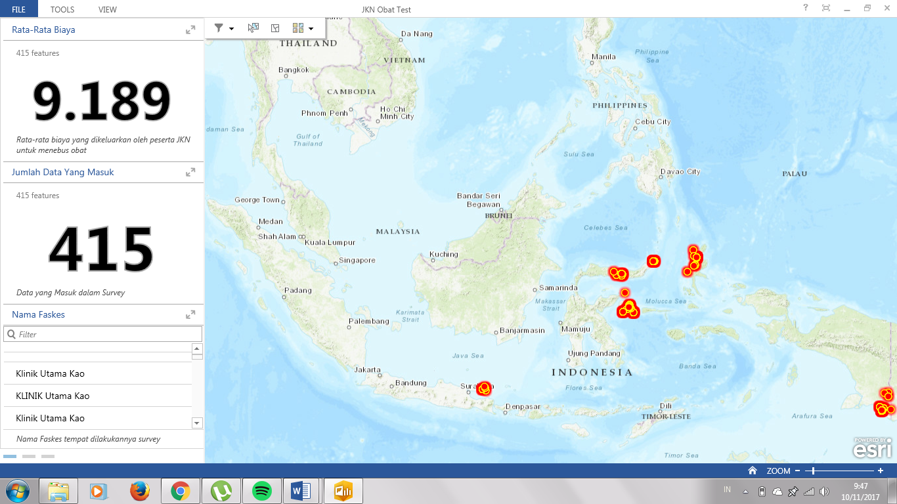
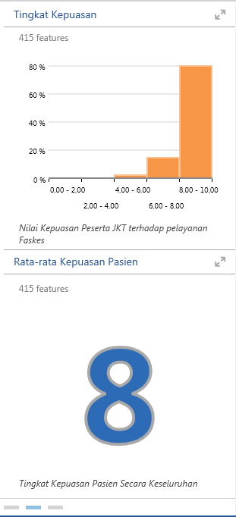

Location of Health Facilities

Average of Satisfactory Level

Total of Health Facility

Figure 3. Analysis of Health Facilities at Coastal Area

Based on data processing result using ArcGIS survey123, the audit team will be able to measure and assess the performance of puskesmas service, healthcare quality, the satisfactory patient level on healthcare service and the cost incurred for getting healthcare service.
As can be seen from the utilization of ArcGIS survey123, there are some major advantages of using ArcGIS survey123 the application in the audit that are:
- User-friendly, this application is easy to operate. The users only need to do an interview and fill in the questionnaire app that already been installed in their smartphones, then submit it to BPK server.
- GIS expertise is only required for analyzing the data.
- Large number of respondents can be obtained in a short time, as the software operator can be anyone and be anywhere as long as the operator is granted access by the Administrator
- the data obtained already has spatial information
- Data is stored securely on the BPK Server
- Stakeholders can access the real-time result of puskesmas performance based on satisfactory patient level.
- The auditor can easily customize the analysis as needed
The application is currently being used to assess the performance of puskesmas located in coastal villages. It is very likely that the application can be implemented on the audit of other aspects of SFM which are the environmental and economic aspects.

