CASE STUDY
THE AUDIT ON CLIMATE CHANGE ADAPTION AND MITIGATION PROGRAM

- Background Information
Climate change impacts to Vietnam are considered to be serious. It is obviously a challenge to the cause of hunger eradication and poverty reduction, the implementation of sustainable development goals, and the country’s sustainable development. Sectors, areas, and localities vulnerable to climate change are defined as Water resources, Agriculture and Food Security, Public Health, Deltas and coastal areas. The Government of Vietnam, with a clear vision on climate change impacts, developed a National Target Program to Respond to Climate Change (NTP-RCC) and the Vietnam Energy Efficiency Programme (VNEEP).
Programme on Climate Change Adaptation and Mitigation (CCAM) is conducted under the Agreement between the Government of the Socialist Republic of Vietnam and the Government of the Kingdom of Denmark regarding a grant for Climate Change Adaptation and Mitigation 2009-2013 and extended to 2015. The CCAM program is divided into two components:
- Climate Change Adaptation (CCA) Component supports the implementation of the National Target Programme to Respond to Climate Change (NTP-RCC) both overall at national level and specifically in the two climate vulnerable provinces, which are Ben Tre and Quang Nam. The focus of the NTP-RCC is on climate change adaptation and the component will therefore focus on this. The lead agency for the NTP-RCC is Ministry of Natural Resources and Environment (MONRE).
- Climate Change Mitigation (CCM) Component supports climate change mitigation through the Vietnam Energy Efficiency Programme under the lead agency mandate of the Ministry of Industry and Trade (MOIT).
The total budget of program is 200 million Danish Kroner, in which 112 millions Danish Kroner is provided for CCA Component, 53 millions Danish Kroner is provided CCM, 30 millions Danish Kroner is used for Technical Support and 5 millions Danish Kroner is used for program management. The Danish financial support will be additional to Vietnamese Government’s own budgetary contribution to the both two components. There will be a balanced focus between supporting physical implementation and capacity building and between support directed at the provincial and national levels.
- Importance of the topic
The development goal of this programme is “Greater sustainability in economic and social development and poverty alleviation in Vietnam through increased capacity of the country to adapt to climate change and increase mitigation efforts”.
At component level, the more specific objectives, which are linked to the two national programmes, are:
- Enhance Vietnam’s capacity and efficiency in response to climate change in order to ensure sustainable development, protect people from harmful impacts of climate change, prevent and reduce risks posed by climate change; join the international community’s efforts to mitigate climate change impacts and protect the global climatic system” (CCA component);
- Improved energy efficiency in Vietnamese enterprises contributes to sustainable development and a low carbon economy (CCM component).
The importance of the program is to assess climate change’s impacts on sectors/areas and regions in specific periods and develop feasible action plan to effective respond to climate change in each short-term/long-term periods to ensure sustainable development of Viet Nam, take over opportunities to develop towards a low-carbon economy, and joint international community’s effort to mitigate climate change impacts and protect global climatic system.
- Audit Objectives:
The objectives of the audit were:
- Check the compliance with regulations and policies relating to the budget, accounting, financial management, public procurement and all other provisions of the Government related to the program.
- To assess the effectiveness of the financial management and administration of ministries and provinces for the program in fiscal year 2015 and whole period from 2011-2015 in view of improving quality, efficiency and transparency in financial management public during the program implementation.
- Check the Treasury accounting system and adherence to regulations and procedures that cover both the Vietnamese Government and Danish Government transferred funds.
Based on the audit report, the Embassy of Denmark desire to have the ability to assess comprehensive financial management and there is a clear picture of where and how to improve the processes and procedures involved.
- Audit Methodologies and Approaches
In accordance with the audit objectives and the State Audit Office of Vietnam’s (SAV) Standards, the audit are carried out in three phases: the planning phase, the conducting phase, and the reporting phase.
During the planning phase, the auditors proceeded with a thorough review of documents provided by related departments, provinces, MONRE, MOIT and the Office of National Target Program to Respond to Climate Change (the Office of the Program) to gain an understanding of the overall legislative and policy framework, as well as the processes relevant to the audit scope. Preliminary interviews were conducted with the Office of the Program to gain greater knowledge of management controls, processes of the program, and to identify key risks associated with the delivery of the program.
The purpose of the planning phase was to develop a Risk-Based Audit Program that provides a basis for the orderly, efficient, and cost effective conduct of the audit as well as a criteria base for assessment.
During the conducting phase, the audit team visited, as per the scope of the audit, headquarters of the Program’s Office in MONRE, MONRE, Ben Tre and Quang Nam provinces. From these visits, the audit team selected documents; conducted interviews, performed project file reviews, and debriefed management on preliminary findings.
Findings for each line of enquiry were summarized and referenced on fact sheets. Facts sheets were prepared for each region and for headquarters and then grouped to reflect audit findings at the program level.
- Audit Fidings
- Management, direction and coordination between some working units was not really sufficient. The Program’s Office did not provide enough consultancies or assign specific plans for individual years.
- The budget usage efficiency of the Program was limited; some projects were implemented tardily resulting in cancelled budget which had influence on the budget allocation for other projects demanding capital.
- Accounting skills of the Program had some limitations, as accountants were inexperienced, lack of professional knowledge.
- The FS preparation, appraisal and approval were not free from errors. As the consequences, right upon the construction completion, an additional sub-project was required, costing more time and efforts in project management and affecting people's living due to prolonged construction period.
- The phase of investigation, design and cost estimates development was not reasonable, which results in changes, adjustments during the implementation process.
- In the Bidding and bidder selection process: Most consultancy packages have had the decision on approving bidding appointment before the date of contract negotiation and this was not relevant. There was also no information about joint responsibilities of the Consortium was provided in the Consortium Agreement.
- The use of energy audit is still limited and inefficient.
- Audit recommendations
- Enforce the guidance, planning, and allocation of the Program's budget to shorten the budget preparation, appraisal period and ensure the timely allocation of budget to spending units. Enhance periodical reporting, preparation of the report on the program's impact assessment.
- Study, carry out Regulation on Procurement, order of public services funded by the State Budget to ensure competition and transparency.
- Direct functional units (Department of Planning, Department of Finance, Department of Hydrology, Meteorology and Climate Change) to review proposals, estimates, products, vouchers, to approve budget adjustment and perform settlement in accordance with the regulation, meeting the requirements of the program budget management and control.
- Direct relevant units to complete the unit price, benchmarks for the tasks in the field of mapping and survey, water management of which, the current unit price is temporary and submit to the competent authority to issue;
- Challenges
- The Vietnamese laws and regulations on environment might not be strictly enough. That causes many obstacles for the investigations and examinations.
- Most of environmental audits performed by the SAV is still largely integrated in the financial statement and compliance audits, not much performance audits with the content of environmental auditing.
- Environmental audits don’t perform independently. Therefore, the audit results are not expressed as expected.
- Lack of SAV’s staff with experience in the environmental auditing.
- Lack of standards, guidelines and manuals on performance audit in general and on environmental auditing in particular to help the State auditors implement environmental audit.
- Co-ordination of the audited units is not inefficient, because of limited awareness of the audited units to the role of SAV in the field of environment.
- During the engagements, many companies do not fully understand the concept of environmental auditing. Therefore, the result of these engagements and the audit reports are only to comply with the requirement of the Law. The value-added from performing an environmental audit is insufficient.
- Solutions:
- Development and Completion of Legal Framework for the SAV’s Organization and Operation: Completion of the State Audit Law and revision of related laws;
- Development of Human Resource: innovation of training and retraining staff; focus on training specialized auditors in the environmental field; appoint auditors to participate in activities of INTOSAI and ASOSAI WGEA;
- Cooperation with other SAI to carry out cooperative audits for learning and sharing mutual experience;
- Recruit professional staff and auditors with appropriate training requirements in the areas of performance audit;
- Development of Guidelines and Methodologies for performance audits, including environmental auditing; Customize INTOSAI and ASOSAI’s Standards, Guidelines and Manuals to appropriate with the context, conditions of Vietnam.
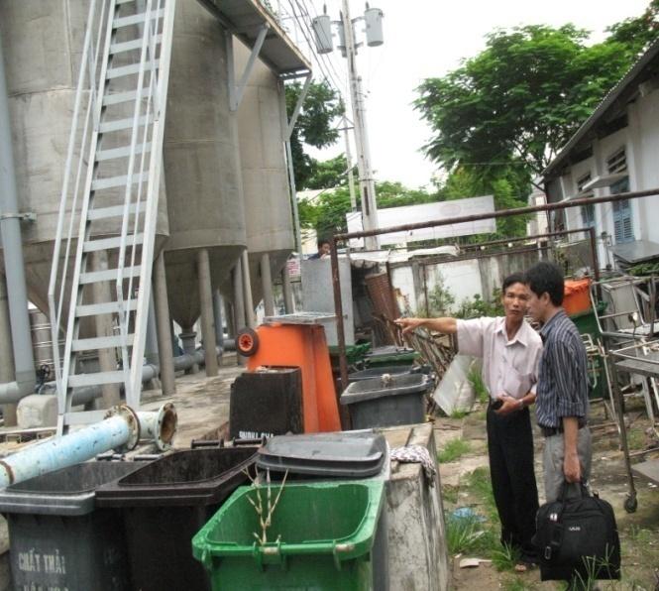 | 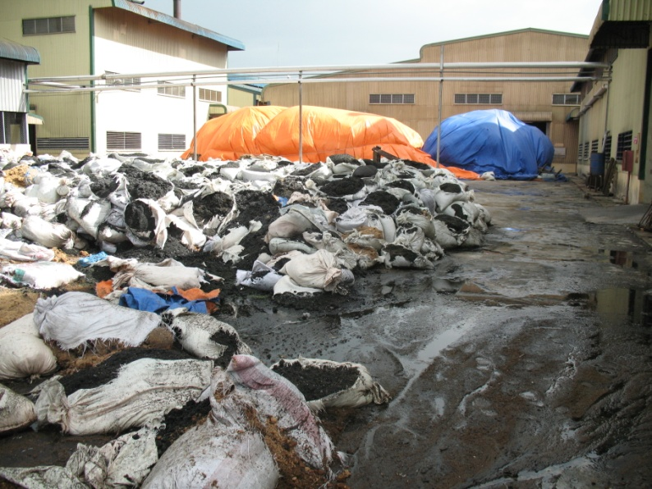
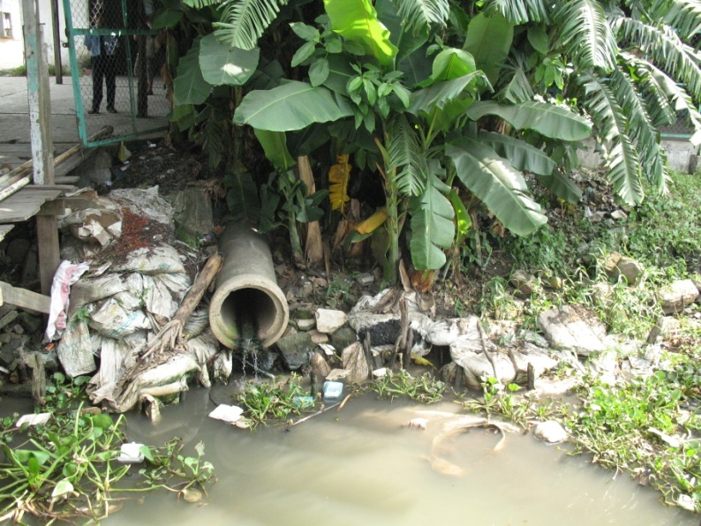 | 